1. **Image Servers**

Below is list of 3 image servers we have in Campbell environment. Two OEL and One RHEL Server.

**Image Servers**

|  |  |
| --- | --- |
| **VMName** | **Description** |
| AMAZRUSESOL7401 | true image for OEL  for SAP servers |
| AMAZRUSESOLORAC | true image for OEL  for DB servers |
| AMAZRUSERHHARD | for all RHEL Linux servers |

1. **Repo Servers**

Below mentioned 2 repo servers.

**Repo Servers**

|  |  |
| --- | --- |
| **VMName** | **Description** |
| OELREPO | Repository Server for OEL |
| RHELREPO | Repository Server for RHEL |

1. **Repo Client**

Below mentioned 3 repo clients. We need 3 repo Clients one for RHEL and two for OEL as we have two images for OEL.

**Repo Client**

|  |  |  |  |  |
| --- | --- | --- | --- | --- |
| **VMName** | **Description** | **OS** | **Kernel Patch before upgrade** | **Kernel Patch After Upgrade** |
| RHELREPOCLIENT03 | RHEL client created from AMAZRUSERHHARD | RHEL 7.4 | 3.10.0-862.3.2.el7.x86_64 | 3.10.0-862.11.6.el7.x86_64 |
| OELREPOCLIENT01 | OELREPOCLIENT01 client created from AMAZRUSESOL7401 | OEL 7.4 | 4.1.12-124.15.1.el7uek.x86_64 | 4.1.12-124.19.5.el7uek.x86_64 |
| OELREPOCLIENT02 | OELREPOCLIENT02 client created from AMAZRUSESOLORAC | OEL 7.4 | 4.1.12-124.15.1.el7uek.x86_64 | 4.1.12-124.19.5.el7uek.x86_64 |

1. **How to add Repository to RHEL Repo Server**

Below commands can be executed to add a new repository on Repo Server

# reposync --gpgcheck -l --repoid= rhui-rhel-7-server-dotnet-rhui-rpms --download_path=/rhelrepo01

# reposync --gpgcheck -l --repoid=rhui-rhel-7-server-dotnet-rhui-rpms --download_path=/rhelrepo01 --downloadcomps --download-metadata

# pwd

/rhelrepo01/rhui-rhel-7-server-dotnet-rhui-rpms

# createrepo -v /rhelrepo01/rhui-rhel-7-server-dotnet-rhui-rpms/ -g comps.xml

1. **Enabling http on RHEL Repo Server**

You need to enable apache on Repo Server, so that repo Client can connect to repo server via http/https to download the rpms.

Create soft link of /var/www/html pointing towards /rhelrepo01 and create index.html in /var/www/html , set the permission and enable and start the apache.

# ls -l /var/www/html

lrwxrwxrwx. 1 root root 11 Sep 18 14:06 /var/www/html -> /rhelrepo01

# cat /var/www/html/index.html

my index file

# chown -R apache:apache /rhelrepo01

#systemctl enable httpd

#systemctl stop httpd

#systemctl start httpd

#systemctl status httpd

● httpd.service - The Apache HTTP Server

Loaded: loaded (/usr/lib/systemd/system/httpd.service; enabled; vendor preset: disabled)

Active: active (running) since Mon 2018-10-01 23:36:07 EDT; 3s ago

Docs: man:httpd(8)

man:apachectl(8)

Process: 3527 ExecStop=/bin/kill -WINCH ${MAINPID} (code=exited, status=0/SUCCESS)

Main PID: 3565 (httpd)

Status: "Processing requests..."

CGroup: /system.slice/httpd.service

├─3565 /usr/sbin/httpd -DFOREGROUND

├─3566 /usr/sbin/httpd -DFOREGROUND

├─3567 /usr/sbin/httpd -DFOREGROUND

├─3568 /usr/sbin/httpd -DFOREGROUND

├─3569 /usr/sbin/httpd -DFOREGROUND

└─3570 /usr/sbin/httpd -DFOREGROUND

Oct 01 23:36:07 RHELREPO systemd[1]: Starting The Apache HTTP Server...

Oct 01 23:36:07 RHELREPO httpd[3565]: AH00558: httpd: Could not reliably determine the server's fully qualifie...ssage

Oct 01 23:36:07 RHELREPO systemd[1]: Started The Apache HTTP Server.

Hint: Some lines were ellipsized, use -l to show in full.

1. **List of All Current Repositories on RHEL REPOSERVER**

We currently have 22 repositories. Please refer to this link to know more details of these repositories.

<https://access.redhat.com/discussions/3434851>

drwxr-x---. 4 apache apache 186 Sep 18 13:15 rhui-rhel-7-server-dotnet-rhui-rpms

drwxr-x--- 4 apache apache 186 Sep 18 17:26 rhui-rhel-7-server-rhui-rpms

drwxr-x--- 3 apache apache 167 Oct 2 02:51 rhui-microsoft-azure-rhel7

drwxr-x--- 4 apache apache 165 Oct 2 02:55 rhui-rhel-7-server-dotnet-rhui-debug-rpms

drwxr-x--- 3 apache apache 145 Oct 2 02:59 rhui-rhel-7-server-dotnet-rhui-source-rpms

drwxr-x--- 4 apache apache 165 Oct 2 06:00 rhui-rhel-7-server-rhui-debug-rpms

drwxr-x--- 4 apache apache 165 Oct 2 09:12 rhui-rhel-7-server-rhui-extras-debug-rpms

drwxr-x--- 4 apache apache 186 Oct 2 09:16 rhui-rhel-7-server-rhui-extras-rpms

drwxr-x--- 3 apache apache 145 Oct 2 09:18 rhui-rhel-7-server-rhui-extras-source-rpms

drwxr-x--- 4 apache apache 165 Oct 2 11:08 rhui-rhel-7-server-rhui-optional-debug-rpms

drwxr-x--- 4 apache apache 165 Oct 2 12:01 rhui-rhel-7-server-rhui-optional-rpms

drwxr-x--- 3 apache apache 4096 Oct 2 12:06 rhui-rhel-7-server-rhui-optional-source-rpms

drwxr-x--- 4 apache apache 165 Oct 2 12:13 rhui-rhel-7-server-rhui-rh-common-debug-rpms

drwxr-x--- 4 apache apache 165 Oct 2 12:20 rhui-rhel-7-server-rhui-rh-common-rpms

drwxr-x--- 3 apache apache 129 Oct 2 12:23 rhui-rhel-7-server-rhui-rh-common-source-rpms

drwxr-x--- 3 apache apache 145 Oct 2 12:24 rhui-rhel-7-server-rhui-source-rpms

drwxr-x--- 3 apache apache 145 Oct 2 12:25 rhui-rhel-7-server-rhui-supplementary-debug-rpms

drwxr-x--- 4 apache apache 186 Oct 2 12:46 rhui-rhel-7-server-rhui-supplementary-rpms

drwxr-x--- 3 apache apache 145 Oct 2 13:09 rhui-rhel-7-server-rhui-supplementary-source-rpms

drwxr-x---. 4 apache apache 252 Oct 2 13:15 rhui-rhel-server-rhui-rhscl-7-debug-rpms

drwxr-x---. 3 apache apache 239 Oct 2 13:27 rhui-rhel-server-rhui-rhscl-7-source-rpms

drwxr-x---. 4 apache apache 280 Oct 2 13:29 rhui-rhel-server-rhui-rhscl-7-rpms

1. **Download rhel-server-7.4-update-4-x86_64-Binarydvd20180125.iso from redhat**

**Note: You need to download one DVD marked in RED.**

**(Officially, we dont have username and password for download CD)**

[**https://access.redhat.com/downloads/content/69/ver=/rhel---7/7.4/x86_64/product-software**](https://access.redhat.com/downloads/content/69/ver=/rhel---7/7.4/x86_64/product-software)

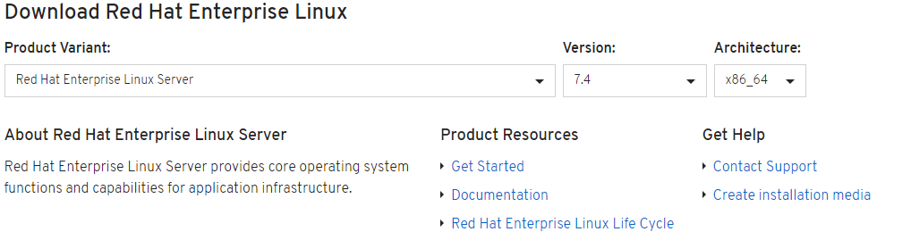

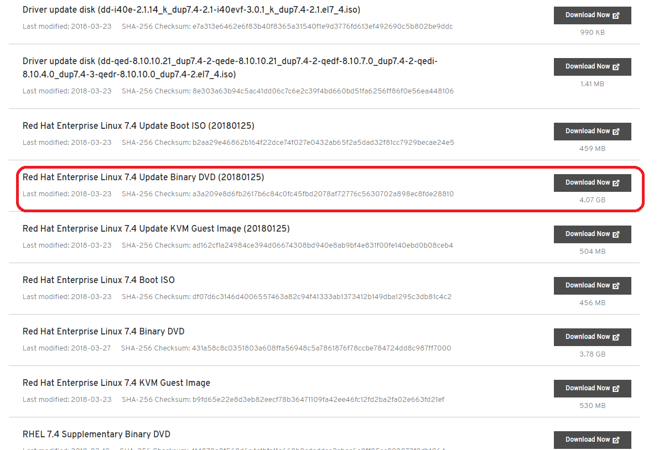

1. **Extract the ISO**

Extract the iso file in /rhelrepo01/rhel-server-7.4-update-dvd20180125.

RHELREPO:/rhelrepo01/rhel-server-7.4-update-dvd20180125 >ls

addons EULA images media.repo rhel-server-7.4-update-4-x86_64-Binarydvd20180125.iso TRANS.TBL

[BOOT] extra_files.json isolinux Packages RPM-GPG-KEY-redhat-beta

EFI GPL LiveOS repodata RPM-GPG-KEY-redhat-release

1. **Update /etc/yum.repos.d/** **rhel_7.4_dvd.repo on RHEL repo Client**



1. **Run yum update on RHEL client.**



1. **Update /etc/yum.repos.d/local-server.repo on RHEL repo Client**

You need to update the /etc/yum.repos.d/local-server.repo file on the linux Repo Clients.

 Please refer to the attachment for RHEL

1. **Updating kernel on RHEL Client**



1. **Rapid 7 Prepatch and Post Patching Reports**

Below are the rapid 7 pre-patch and post-patch reports for comparision.



1. **OMS agent and OMI Server - on Client (if required)**

Update OMS Agent

# wget --no-check-certificate https://github.com/Microsoft/OMS-Agent-for-Linux/releases/download/OMSAgent_v1.6.1.3/omsagent-1.6.1-3.universal.x64.sh

# sh omsagent-1.6.1-3.universal.x64.sh –purge

# sh omsagent-1.6.1-3.universal.x64.sh --upgrade -w b9698bae-151d-4800-9388-37b4f83608a2 -s 985veLMio7UOxQHHOB0boncA0CbQuxiTF89SE5rujtlIXtqOBX3XsY5QtB+wshAh1NJ++qOpIGuANmx1uCaNNw==

# sudo su omsagent -c 'python /opt/microsoft/omsconfig/Scripts/PerformRequiredConfigurationChecks.py'

View OMI Server version

# /opt/omi/bin/omiserver -v

/opt/omi/bin/omiserver: OMI-1.4.2-5 - Wed Jul 25 10:59:15 PDT 2018

Reading OMS Agent configuration file

# cat "/etc/opt/microsoft/omsagent/b9698bae-151d-4800-9388-37b4f83608a2/conf/omsagent.conf"

Reading OMI Server Configuration file

# cat /etc/opt/omi/conf/omiserver.conf

Restarting OMS Agent

#  /opt/microsoft/omsagent/bin/service_control restart

Restarting OMI Server

# /opt/omi/bin/service_control restart

Viewing Logs of OMS Agent

# tail -f /var/opt/microsoft/omsagent/log/omsagent.log

Viewing OMI Server log file

# tail /var/opt/omi/log/omiserver.log

Check for python

# rhelrepoclient:/root >ps -ef | grep -i python

root 1481 1 0 01:21 ? 00:00:00 /usr/bin/python -Es /usr/sbin/tuned -l -P

root 1484 1 0 01:21 ? 00:00:00 /usr/bin/python -u /usr/sbin/waagent -daemon

root 1727 1484 4 01:21 ? 00:01:22 python -u bin/WALinuxAgent-2.2.26-py2.7.egg -run-exthandlers

root 2837 1 0 01:23 ? 00:00:00 python /var/lib/waagent/Microsoft.OSTCExtensions.LinuxDiagnostic-2.3.9029/diagnostic.py -daemon

root 3137 1 0 01:23 ? 00:00:00 python /var/lib/waagent/Microsoft.EnterpriseCloud.Monitoring.OmsAgentForLinux-1.7.9/omsagent.py -telemetry

nxautom+ 4225 1 0 01:30 ? 00:00:00 python /opt/microsoft/omsconfig/modules/nxOMSAutomationWorker/DSCResources/MSFT_nxOMSAutomationWorkerResource/automationworker/worker/main.py /var/opt/microsoft/omsagent/state/automationworker/oms.conf rworkspace:b9698bae-151d-4800-9388-37b4f83608a2 1.6.2.0

nxautom+ 4249 1 0 01:30 ? 00:00:00 python /opt/microsoft/omsconfig/modules/nxOMSAutomationWorker/DSCResources/MSFT_nxOMSAutomationWorkerResource/automationworker/worker/hybridworker.py /var/opt/microsoft/omsagent/state/automationworker/worker.conf managed rworkspace:b9698bae-151d-4800-9388-37b4f83608a2 rversion:1.6.2.0

omsagent 7873 7847 1 01:53 ? 00:00:01 python /opt/microsoft/omsconfig/Scripts/client.py 14

omsagent 7876 7847 0 01:53 ? 00:00:00 python /opt/microsoft/omsconfig/Scripts/client.py 14

omsagent 7879 7847 0 01:53 ? 00:00:00 python /opt/microsoft/omsconfig/Scripts/client.py 14

omsagent 7882 7847 0 01:53 ? 00:00:00 python /opt/microsoft/omsconfig/Scripts/client.py 14

omsagent 7891 7847 0 01:53 ? 00:00:00 python /opt/microsoft/omsconfig/Scripts/client.py 14

omsagent 8024 7847 0 01:54 ? 00:00:00 python /opt/microsoft/omsconfig/Scripts/client.py 14

omsagent 8090 7847 2 01:54 ? 00:00:00 python /opt/microsoft/omsconfig/Scripts/client.py 14

root 8182 5851 0 01:55 pts/0 00:00:00 grep --color=auto -i python

rhelrepoclient:/root >